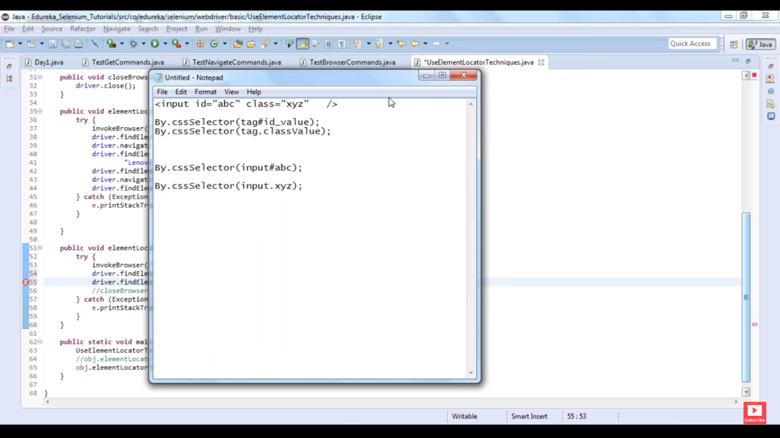

Commands: isEnabled, isDisplayed, isSelected

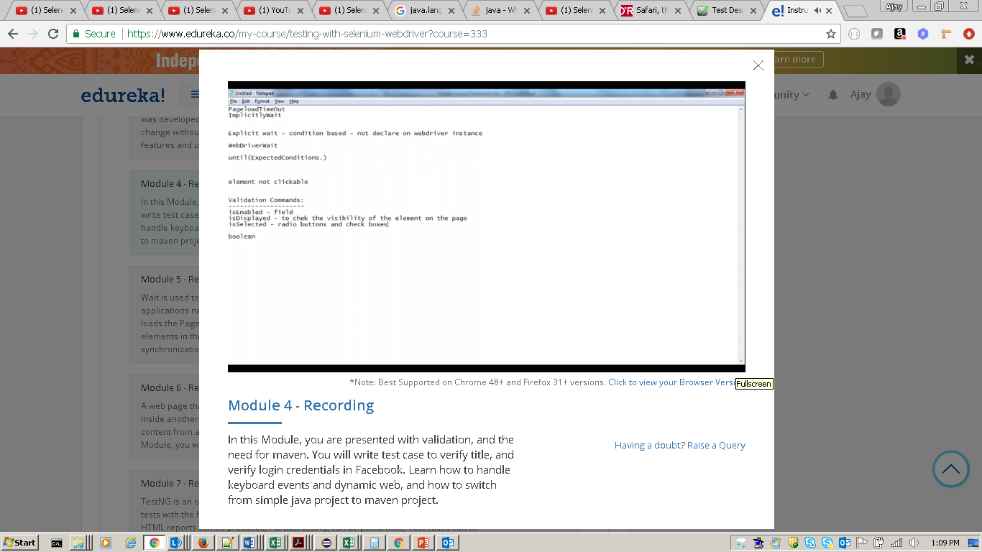

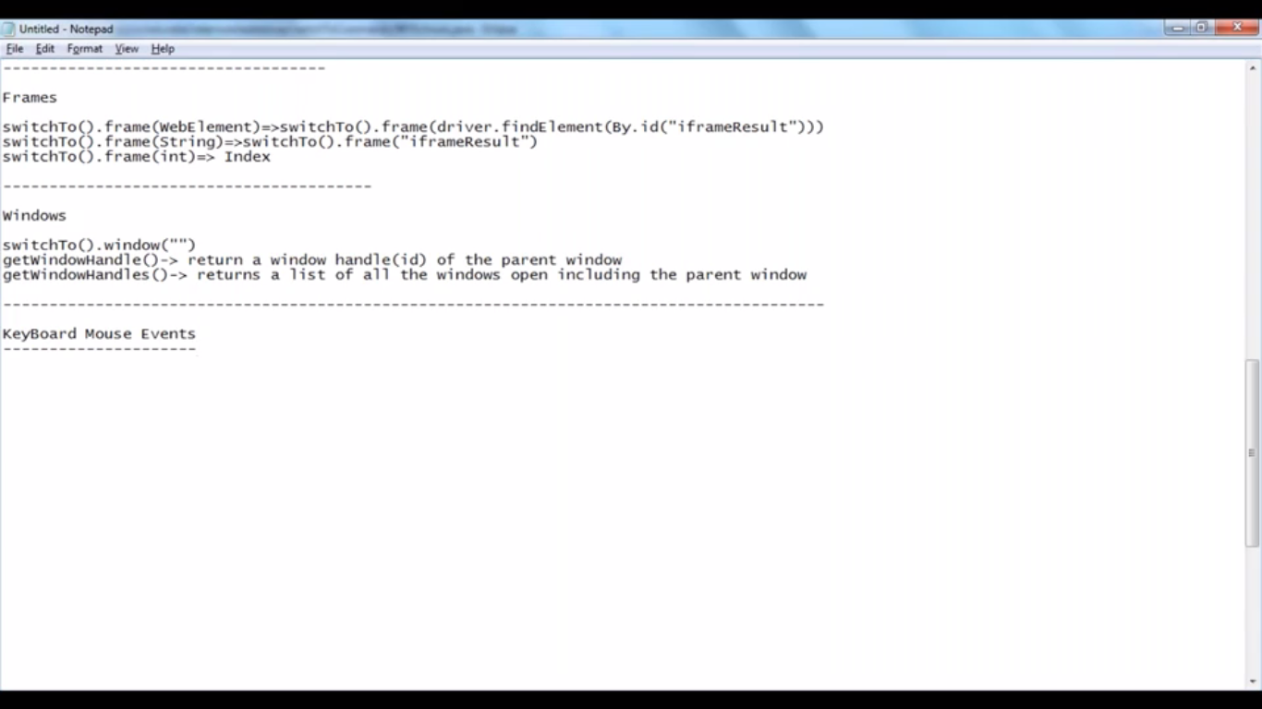

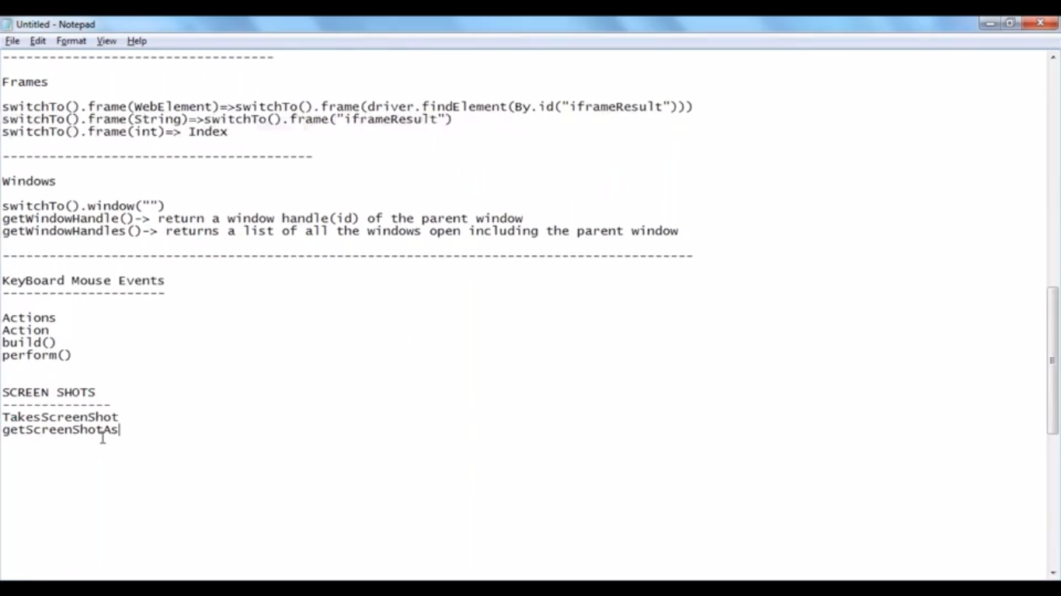

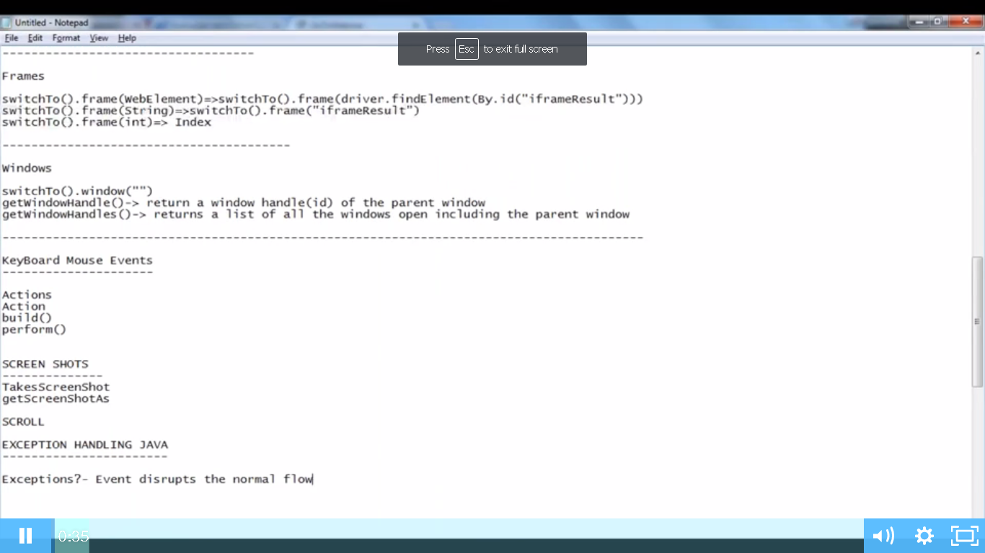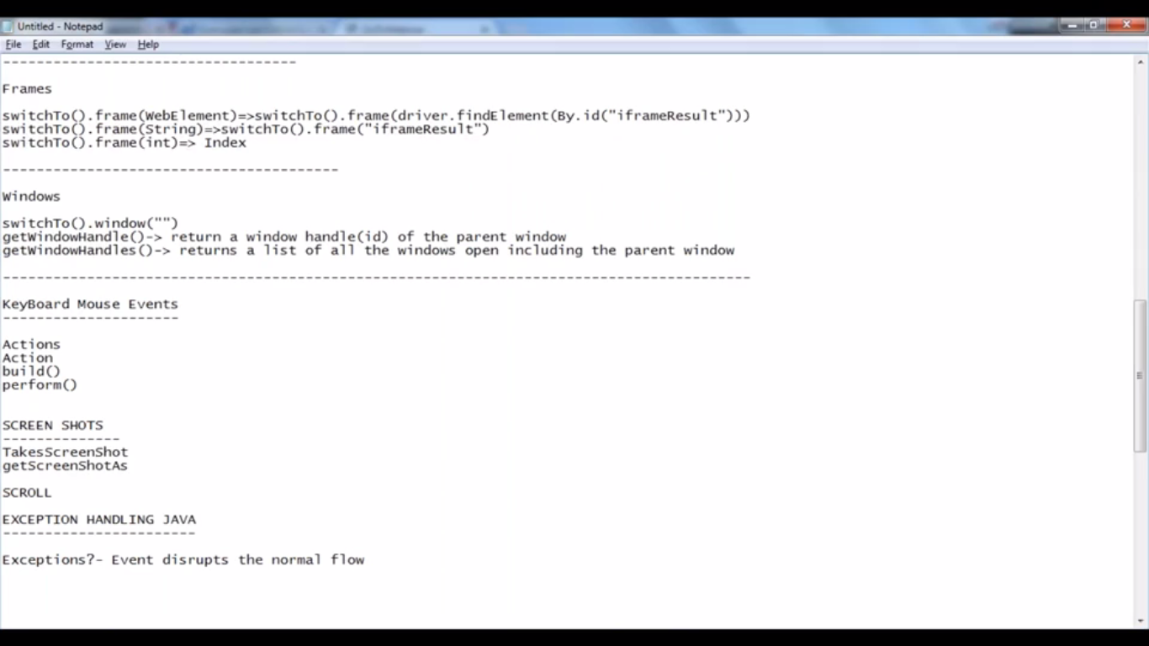

Handling of exception event exception.

Get Commands

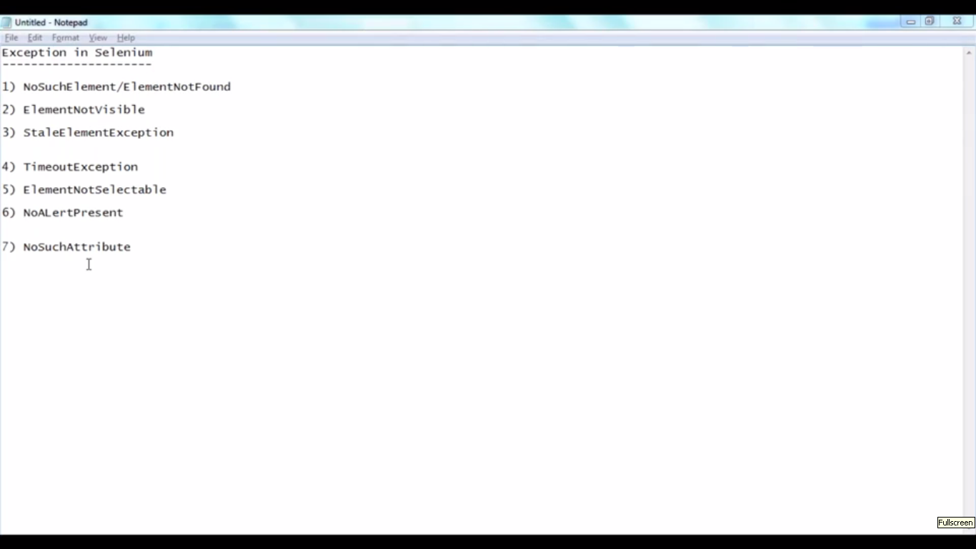

Validation command: is displayed, is enabed, is selected

Navigate commands

Explicit wait

Implicit wait; webdriver wait

Keyboard Mouse events

Send keys

Shift up

Shift down

Screen shot and scroll.

